**Perfect Competition**

Perfect competition is a market structure characterized by a complete absence of rivalry among the individual firms. Thus perfect competition in economic theory has a meaning diametrically opposite to the everyday use of this term. In practice businessmen use the word competition as synonymous to rivalry. In theory, perfect competition implies no rivalry among firms.

**ASSUMPTIONS:**

The model of Perfect competition isbased on the following assumptions.

**1.Large numbers of sellers and buyers**

The industry or market includes a large number of firms (and buyers), so that each individual firm, however large, supplies only a small part of the total quantity offered in the market The buyers are also numerous so that no monopsonistic power can affect the working of the market Under these conditions each firm alone cannot affect the price in the market by changing its output.

**2.Product homogeneity**

the products of different firm If the product were differentiated the firm would have some discretion in setting its price.

The assumptions of large numbers of sellers and of product homogeneity imply that the individual firm in pure competition is a price-taker: its demand curve is infinitely elastic, indicating that the firm can sell any amount of output at the prevailing market

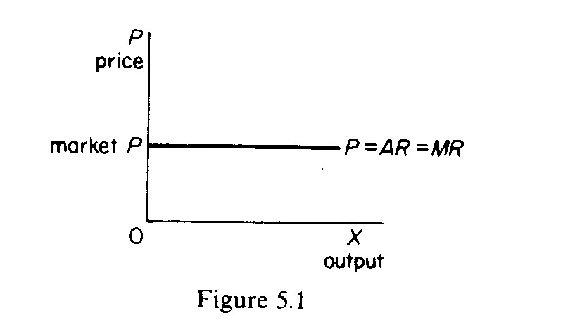

price (figure 5.1). The demand curve of the individual firm is also its average revenue and its marginal revenue curve (see page 156).

**3.Free entry and exit of firms:**

There is no barrier to entry or exit from the industry. Entry or exit may take time, but firms have freedom of movement in and out of the industry. This assumption is supplementary to the assumption of large numbers. If barriers exist the number of firms in the industry may be reduced so that each one of them may acquire power to affect the price in the market.

**4.Profit maximisation:**

The goal of all firms is profit maximisation. No other goals are pursued.

**5.No government regulation:**

There is no government intervention in the market (tariffs, subsidies, rationing of production or demand and so on are ruled out).The above assumptions are sufficient for the firm to be a price-taker and have an infinitely elastic demand curve.

The market structure in which the above assumptions are fulfilled is called ***pure competition.***It is different from *perfect competition,* which requires the fulfillment of the following additional assumptions.

**6.Perfect mobility of factors of production**

The factors of production are free to move from one firm to another throughout the economy. It is also assumed that workers can move between different jobs, which implies that skills can be learned easily. Finally, raw materials and other factors are not monop­olised and labour is not unionised. In short, there is perfect competition in the markets of factors of production.

**7.Perfect knowledge:**

It is assumed that all sellers and buyers have complete knowledge of the conditions of the market. This knowledge refers not only to the prevailing conditions in the current period but in all future periods as well. Information is free and costless. Under these conditions uncertainty about future developments in the market is ruled out.

**EQUILIBRIUM OF THE FIRM IN THE SHORT RUN**

The firm is in equilibrium when it maximises its profits (π), defined as the difference between total cost and total revenue:

π =TR-TC

The firm is in equilibrium when it produces the output that maximises the difference between total receipts and total costs. The equi­librium of the firm may be shown graphically in two ways. Either by using the *TR* and TC curves, or the *MR* and MC curves.

In figure 2 we show the total revenue and total cost curves of a firm in a perfectly competitive market. The total-revenue curve is a straight line through the origin, showing that the price is constant at all levels of output. The firm is a price-taker and can sell any amount of output at the going market price, with its *TR* increasing pro­portionately with its sales. The slope of the *TR* curve is the marginal revenue. It is constant and equal to the prevailing market price, since all units are sold at the same price. Thus in pure competition *MR = AR = P.*

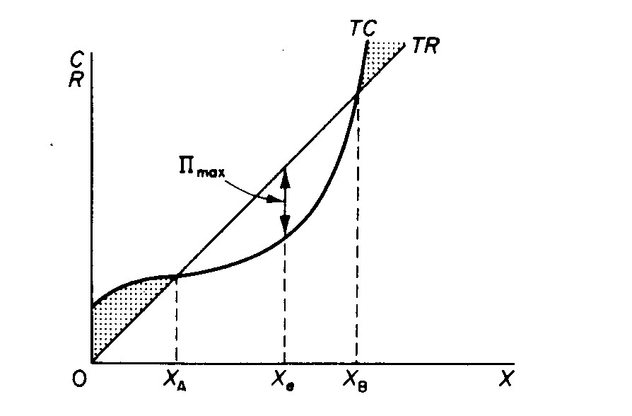

Figure *2*

The shape of the total-cost curve reflects the U shape of the average-cost curve, that is, the law of variable proportions. The firm maximises its profit at the output X., where the distance between the *TR* and TC curves is the greatest. At lower and higher levels of output total profit is not maximised: at levels smaller than X,, and larger than X*B* the firm has losses.

In figure 3 we show the average- and marginal-cost curves of the firm together with its demand curve. We said that the demand curve is also the average revenue curve and

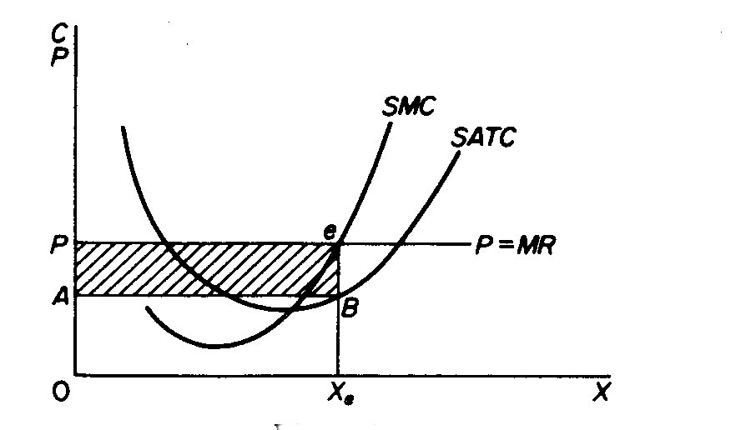

Figure *3*

the marginal revenue curve of the firm in a perfectly competitive market. The marginal cost cuts the SATC at its minimum point. Both curves are U-shaped, reflecting the law of variable proportions which is operative in the short run during which the plant is constant. The firm is in equilibrium (maximises its profit) at the level of output defined by the intersection of the *MC* and the *MR* curves (point *e* in figure3). To the left of *e* profit has not reached its maximum level because each unit of output to the left of Xe brings to the firm a revenue which is greater than its marginal cost. To the right of Xe each additional unit of output costs more than the revenue earned by its sale, so that a loss is made and total profit is reduced. In summary:

(a) If *MC < MR* total profit has not been maximised and it pays the firm to expand its output.

(6) If *MC > MR* the level of total profit is being reduced and it pays the firm to cut its production.

(c) If *MC = MR* short-run profits are maximised.

Thus the **first condition** for the equilibrium of the firm is **that marginal cost be equal to marginal revenue.** However, this condition is not sufficient, since it may be fulfilled and yet the firm may not be in equilibrium. In figure 4 we observe that the condition

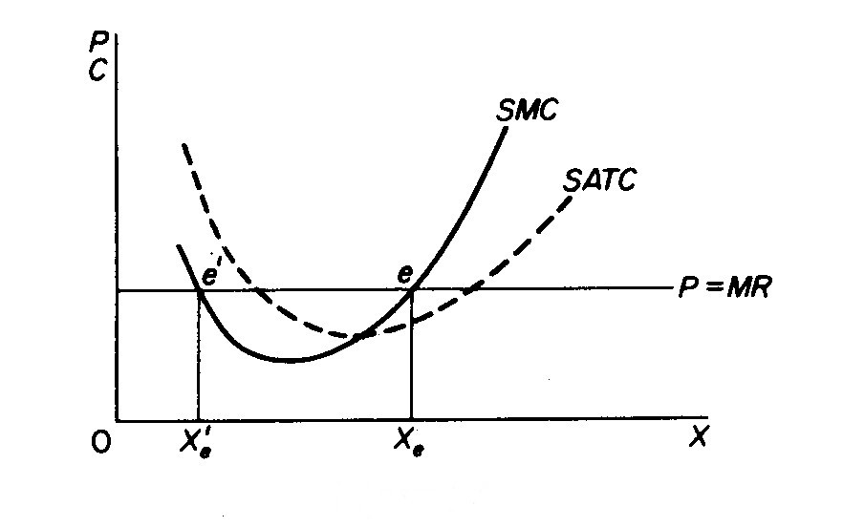

**Figure** *4*

*MC = MR* is satisfied at point e', yet clearly the firm is not in equilibrium, since profit is maximized at Xe *>* Xe´The **second condition** for equilibrium requires that **the *MC* be rising at the point of its intersection with the *MR* curve.**

This means that the *MC* must cut the *MR* curve from below, i.e. the slope of the *MC* must be steeper than the slope of the *MR* curve. In figure 4 the slope of *MC* is positive at *e,* while the slope of the *MR* curve is zero at all levels of output. Thus at *e* both conditions for equilibrium are satisfied

(i) *MC = MR* and

(ii) (slope of *MC) >* (slope of MR).

It should be noted that the *MC* is always positive, because the firm must spend some money in order to produce an additional unit of output. Thus at equilibrium the *MR* is also positive.

The fact that a firm is in (short-run) equilibrium does not necessarily mean that it makes excess profits. Whether the firm makes excess profits or losses depends on the level of the ATC at the short-run equilibrium. If the ATC is below the price at equilibrium (figure 5.5) the firm earns excess profits (equal to the area *PABe).* If, however, the ATC is above the price (figure 5.6) the firm makes a loss (equal to the area *FPeC)*

*.*

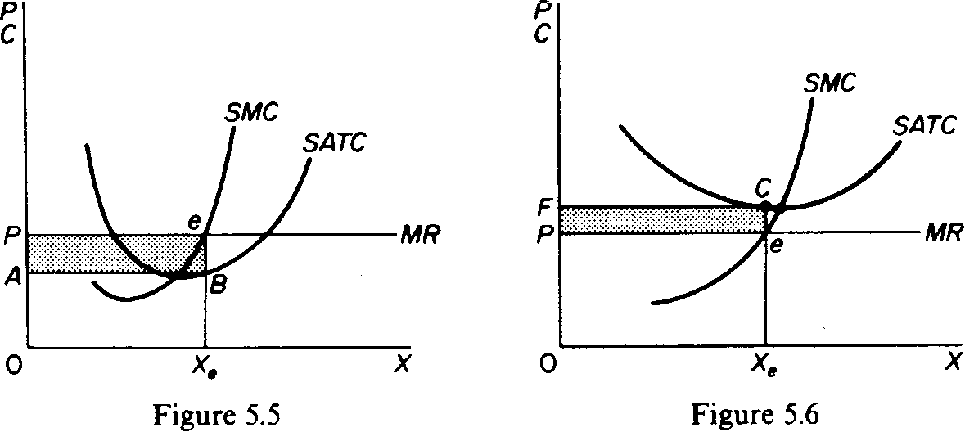

If the firm incur losses, it will continue to produce only if it covers its variable costs. Otherwise it will close down, since by discontinuing its operations the firm is better off: it mimimises its losses. The point at which the firm covers its variable costs is called the closing-down point. In figure 5.7 the closing-down point of the firm is denoted by point w. If price falls below Pw the firm does not cover its variable costs and is better off if it closes down.

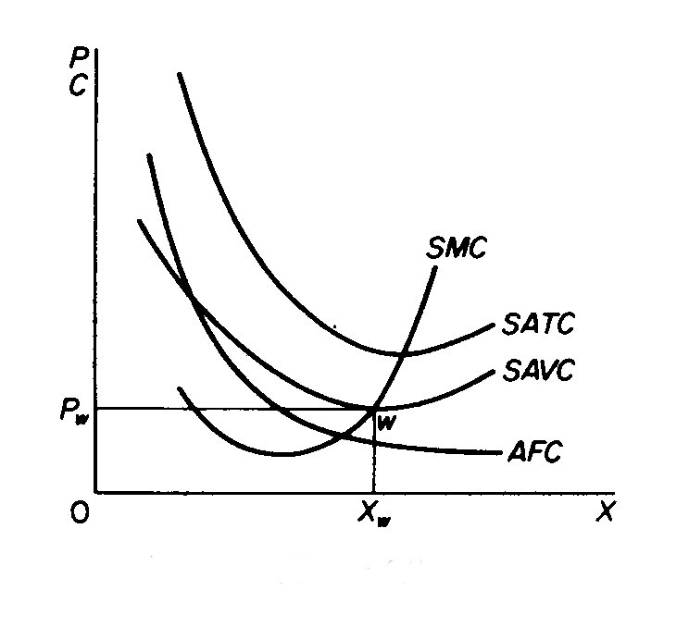

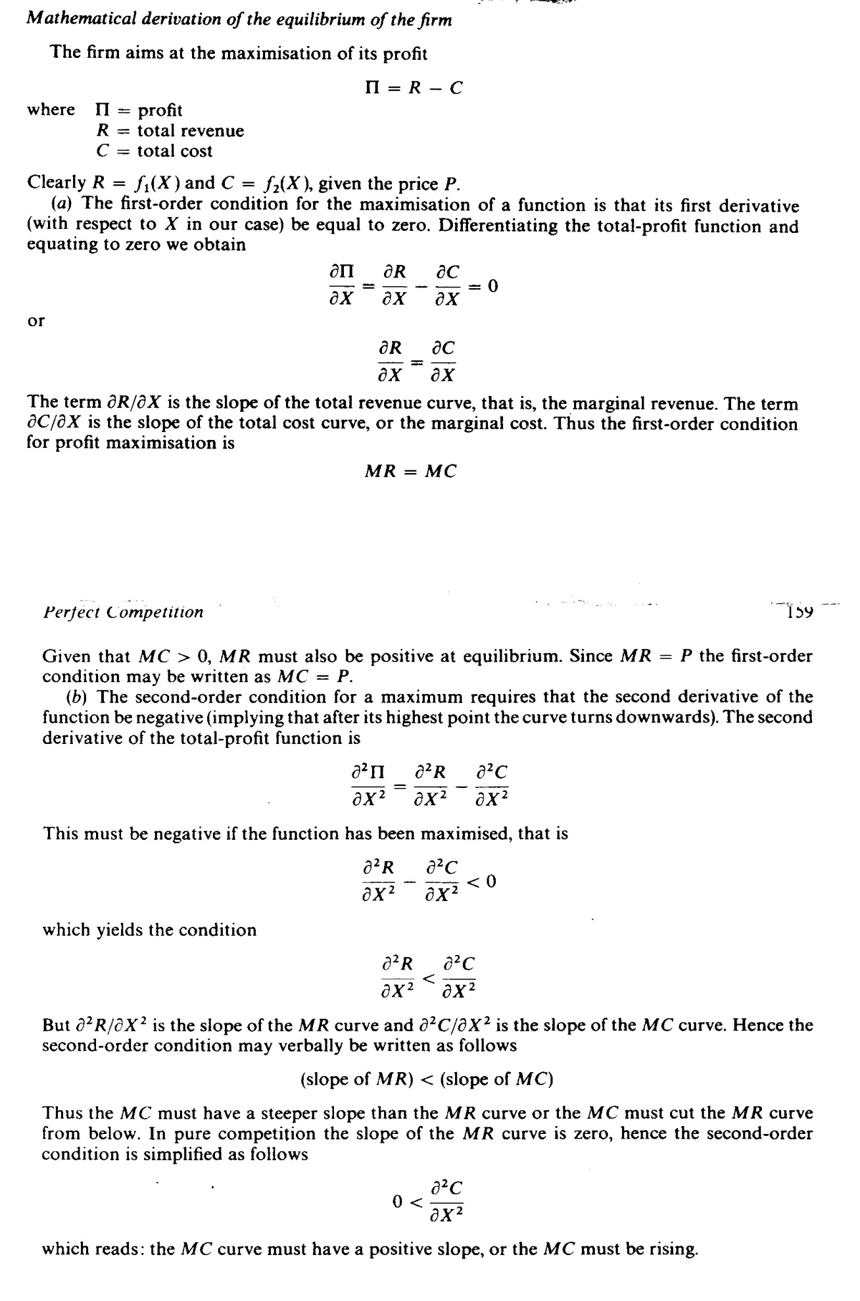

**THE SUPPLY CURVE OF THE FIRM AND THE INDUSTRY**

The supply curve of the firm may be derived by the points of intersection of its *MC* curve with successive demand curves. Assume that the market price increases gradually. This causes an upward shift of the demand curve of the firm. Given the positive slope of the *MC* curve, each higher demand curve cuts the (given) *MC* curve to a point which lies to the right of the previous intersection. This implies that the quantity supplied by the firm increases as price rises. The firm, given its cost structure, will not supply any quantity (will close down) if the price falls below PW, because at a lower price the firm does not cover its variable costs (figure 5.8). If we plot the successive points of intersec­tion of MC and the demand curves on a separate graph we observe that the supply curve of the individual firm is identical to its MC curve to the right of the closing-down point w. Below P„, the quantity supplied by the firm is zero. As price rises above PW the quantity supplied increases. The supply curve of the firm is shown in figure 5.9.

The industry-supply curve is the horizontal summation of the supply curves of the individual firms. It is assumed that the factor prices and the technology are given and that the number of firms is very large. Under these conditions the total quantity supplied in the market at each price is the sum of the quantities supplied by all firms at that price. In figure 5.10 we show the industry supply as a straight line with a positive slope. It should, however, be noted that the particular shape of the market-supply curve depends on the technology and on factor prices, as well as the size distribution of the firms in the industry. All firms are not usually of the same size. The particular size of each firm in perfect competition depends on the entrepreneurial efficiency of the businessman, which is traditionally considered as a random attribute.

(slope of *MR) <* (slope of *MC)*

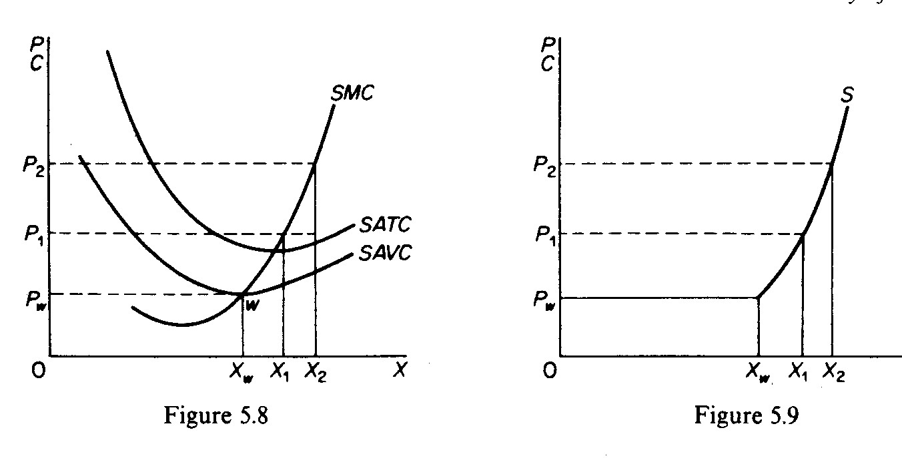

**EQUILIBRIUM OF THE FIRM IN THE LONG RUN**

In the long run firms are in equilibrium when they have adjusted their plant so as to produce at the minimum point of their long-run AC curve, which is tangent (at this point) to the demand curve defined by the market price. In the long run the firms will be earning just normal profits, which are included in the LAC. If they are making excess profits new firms will be attracted in the industry; this will lead to a fall in price (a down-ward shift in the individual demand curves) and an upward shift of the cost curves due to the increase of the prices of factors as the industry expands. These changes will continue until the *LAC* is tangent to the demand curve defined by the market price. If the firms make losses in the long run they will leave the industry, price will rise and costs may fall as the industry contracts, until the remaining firms in the industry cover their total costs inclusive of the normal rate of profit.

In figure 5.14 we show how firms adjust to their long-run equilibrium position. If the price is P, the firm is making excess profits working with the plant whose cost is denoted by *SAC,.* It will therefore have an incentive to build new capacity and it will move along its *LAC.* At the same time new firms will be entering the industry attracted by the excess profits. As the quantity supplied in the market increases (by the increased production of expanding old firms and by the newly established ones) the supply curve in the market will shift to the` right and price will fall until it reaches the level of 'P, (in figure 5.13) at which the firms and the industry are in long-run equilibrium. The *LAC* in figure 5.14 is the final-cost curve including any increase in the prices of factors that may have taken place as the industry expanded.

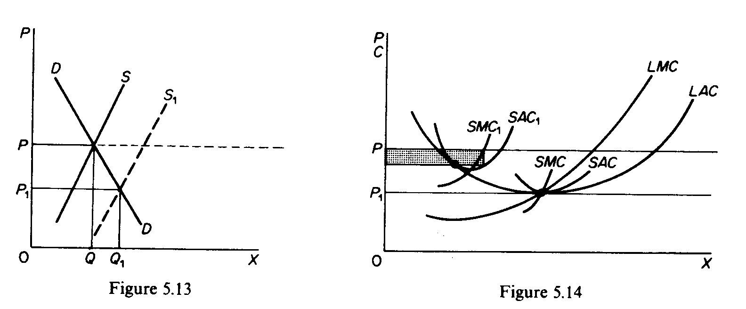

The condition for the long-run equilibrium of the firm is that the marginal cost be equal to the price and to the long-run average cost

*LMC = LAC = P*

The firm adjusts its plant size so as to produce that level of output at which the *LAC* is the minimum possible, given the technology and the prices of factors of production. At equilibrium the short-run marginal cost is equal to the long-run marginal cost and the short-run average cost is equal to the long-run average cost. Thus, given the above equilibrium condition, we have

SAC=*SMC=LMC=LAC=P=MR*

This implies that at the minimum point of the *LAC* the corresponding (short-run) plant is worked at its optimal capacity, so that the minima of the *LAC* and *SAC* coincide. On the other hand, the *LMC* cuts the *LAC* at its minimum point and the *SMC* cuts the *SAC* at its minimum point. Thus at the minimum point of the *LAC* the above equality between short-run and long-run costs is satisfied. .

**SHORT-RUN EQUILIBRIUM OF THE INDUSTRY**

Given the market demand and the market supply the industry is in equilibrium at that price which *clears the market,* that is at the price at which the quantity demanded is equal to the quantity supplied. In figure 5.10 the industry is in equilibrium at price P, at which the quantity demanded and supplied is Q. However, this will be a short-run equilibrium, if at the prevailing price firms are making excess profits (figure 5.11) or losses (figure 5.12). In the long run, firms that make losses and cannot readjust their plant will close down. Those that make excess profits will expand their capacity, while excess profits will also attract new firms into the industry. Entry, exit and readjustment of the remaining firms in the industry will lead to a long-run equilibrium in which firms will just be earning normal profits and there will be no entry or exit from the industry.

